Getting Started
The Patient Triage solution allows patients to submit either a medical query or an administrative request to their registered GP practice.
Please note! If your medical query is urgent then contact ‘111’ or for a medical emergency contact, ‘999’.
When wanting to submit a query to your GP practice you will need to visit their website. A link should be provided that allows you to begin submitting your query. However, if this is not clear then you will need to contact your GP practice.
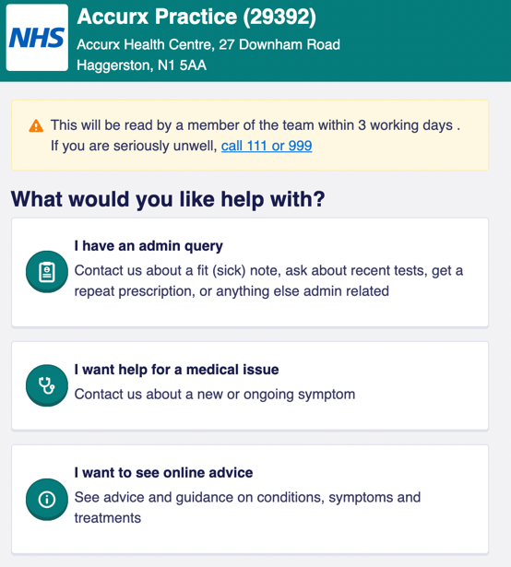
When selecting the link you will be able to see the name of your practice, the address of the practice, a standard warning message indicating the expected duration for your query to be responded to, and information on what to do if your query is a medical emergency.
Below this information are three choices to select from based on the nature of your query.
“I have an admin query”
Selecting this option will allow you to:
- Request a doctor's note
- Request a fit (sick) note
- Ask questions or get an update on a referral
- Follow-up on Test Results (Blood Test, Scans, etc.)
- Any other advice or information that is not medical related
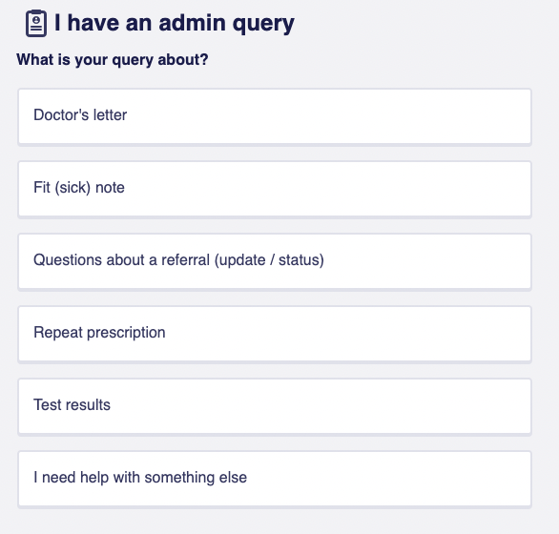
“I want help for a medical issue”
Selecting this option will allow you to submit a request to get help regarding a medical issue. You will be asked to provide the following:
- A description of the medical problem (Option to attach up to 5 photos)
- Describe how long you have experienced symptoms or had concerns as well as whether these symptoms/concerns have gotten better or worse.
- Describe whether you are particularly worried about.*
- How you would like your GP practice can help.
- List times that you are not available during GP opening times.*
* = are options fields and do not require you to enter any information if you don’t want/need to.
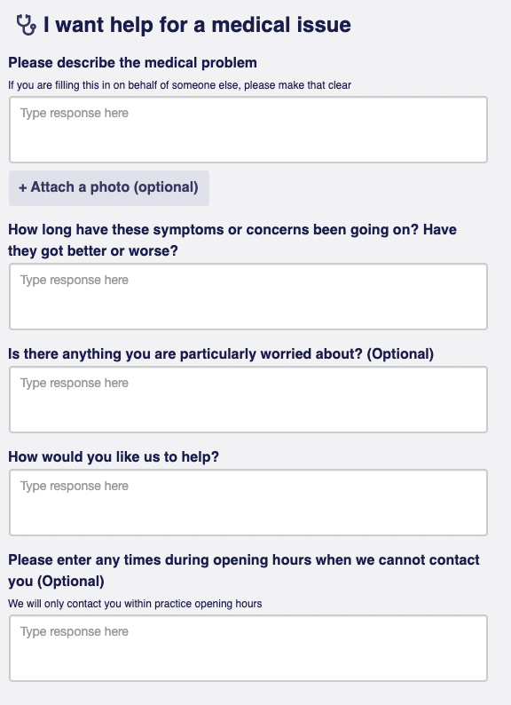
“I want to see online advice”
This option will signpost you to the NHS website for additional information.
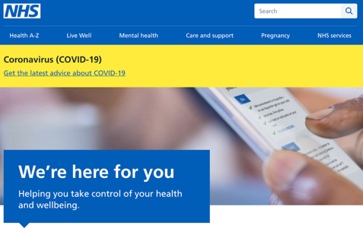

Medical Urgency Check
Following the option you select, you will be asked to confirm whether you are experiencing any of the below symptoms.

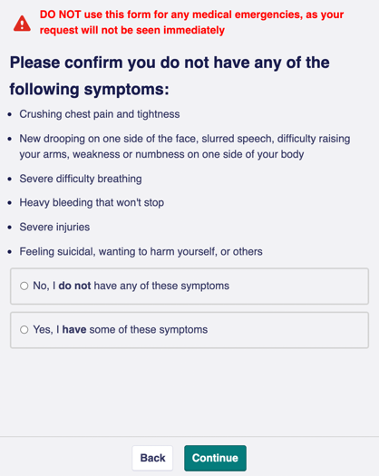
If you are experiencing any of these symptoms and acknowledge this you will be signposted to the emergency services.

Coronavirus Screening
When completing a medical query form you will be asked to confirm whether you or someone in your household has tested positive for coronavirus within the last 14 days and if you have any of the listed symptoms.
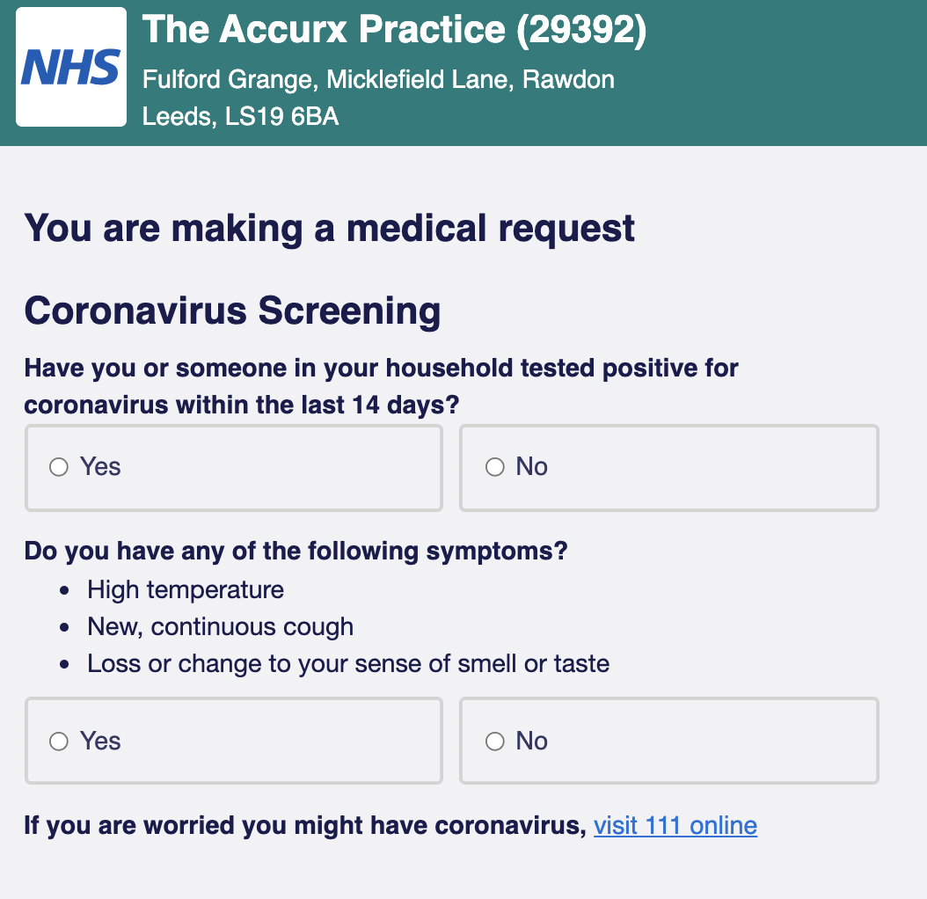

Personal Details
You will be asked to provide your personal details before submitting your request. Providing this information will allow your GP to match your medical record to the request you have submitted in this form.
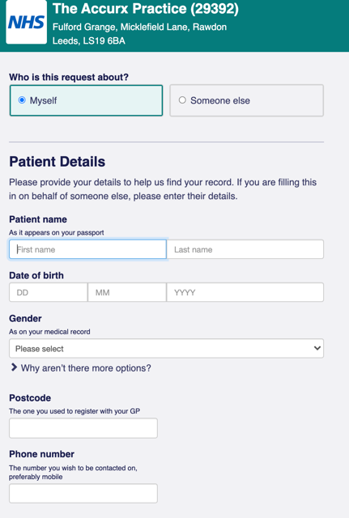
If you are submitting this form on behalf of someone else then you will be asked to provide your own details along with the person’s details that you are submitting this form. Examples of when and might be the case will include (but not limited to);
- You are the person’s guardian/parent.
- You are the person’s carer.
- You are contacting the practice and have asked the receptionist to complete this for you.
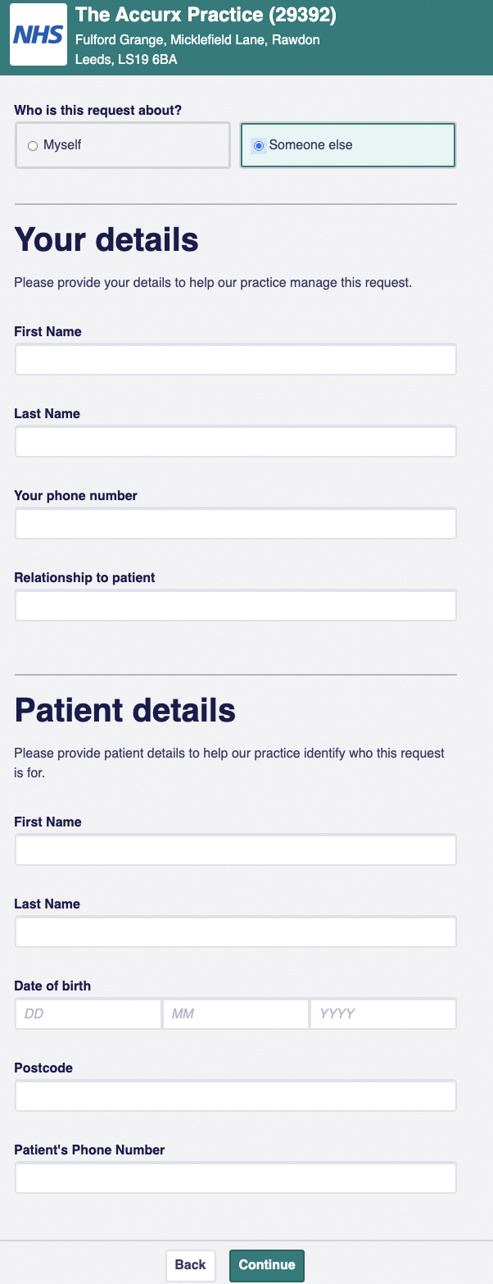
Once you have completed your details and entered your phone number* you will then be asked whether you have access to the phone this number is connected to.
*= You must ensure that you enter a valid UK mobile number.
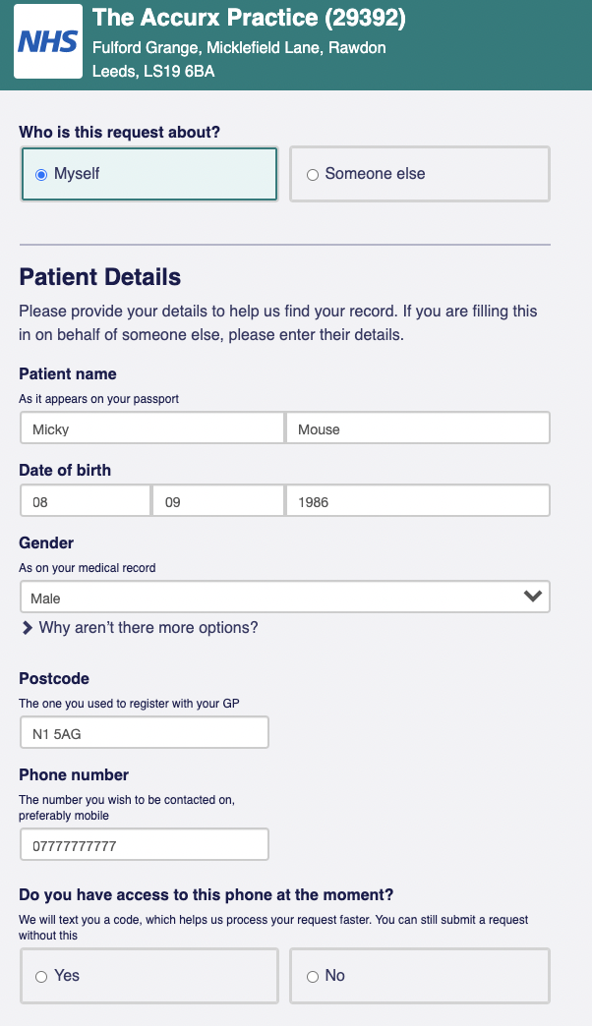
What happens if I select, ‘Yes’?
If you click ‘Yes’ and then ‘Continue’ you will be sent an SMS message with a unique code to enter on the next page (see below). This is known as a two-step authentication process. It allows your GP to match your request to your health record much faster.
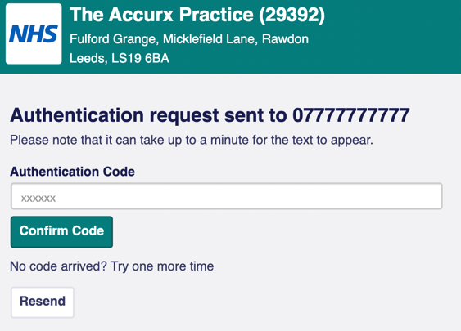
What happens if I select, ‘No’?
If you click ‘No’ then you will be able to continue to complete the form however, it may mean that there will be a slight delay in your request being completed. Your GP will have to manually locate your health record and match it with your request.

Confirming Your Request
Once you are satisfied with the information you have provided and you have provided your details (and completed the two-step verification process) then you will be able to:
- Confirm you are sending this to the correct practice,
- Confirm that all the information you have provided is relevant and accurate,
- Confirm that you have entered your personal details correctly,
- State the best method to contact you, ‘Text message’, ‘Phone Call’ and/or ‘Video Call’,
- If you would like to receive a confirmation text of your request once submitted.
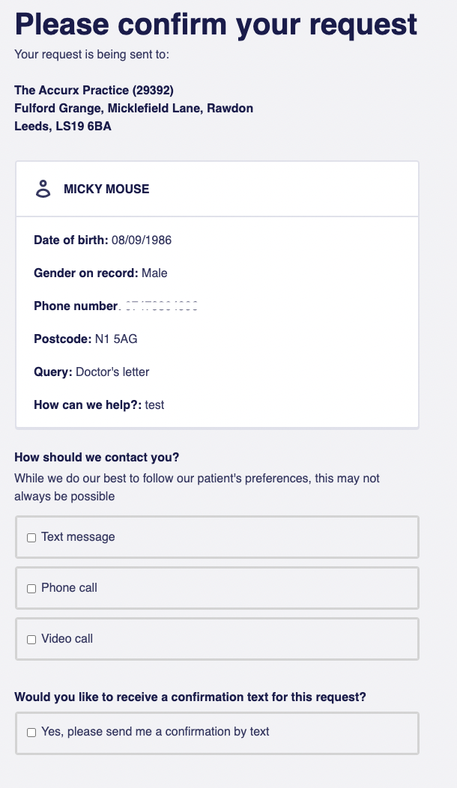
When you are finished you will need to select the, ‘Submit Request’ button at the bottom of the screen.
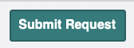
Following that, you will be navigated to the next page confirming that your request form has been sent along with verification via text if you chose to receive this.
If you ever have any technical issues completing the form then drop our Support Team a message via the Help Center on our website.
Please note, that we are not medical professionals and so, you should refrain from contacting us with medical queries/issues.

